**Capstone Project - The Battle of Neighborhoods**

**UK Cities Restaurants Analysis**

## Data:

This project is mainly based on:

* Foursquare Data location API.
* United Kingdom Cities Database from "simplemaps" site <https://simplemaps.com/data/gb-cities>.

**The UK data file includes some information about the cities of UK :**

* City
* Lat
* Lng
* Country
* iso2
* admin_name
* capital
* population
* population_proper

Step 1 - Extracting UK Data File:

the idea here is to get information from the CSV file of UK and convert it to a data frame including the city name, coordinates (longitude and latitude) and population per city.

Step 2 – Foursquare API:

After that we will be using the Foursquare API with the Search capability to get all restaurant venues per city.

Step 3 – Clustering:

After compiling all information that we got from the UK database and the Foursquare API, we will end up with a database including 4 major information:

1. City Name (all UK cities).
2. Population Per city.
3. Number of restaurants per city.
4. Restaurant per 100K capita. (an indication feature of how many restaurants exists in a city per 100K person).

## Methodology:

## Import all necessary libraries

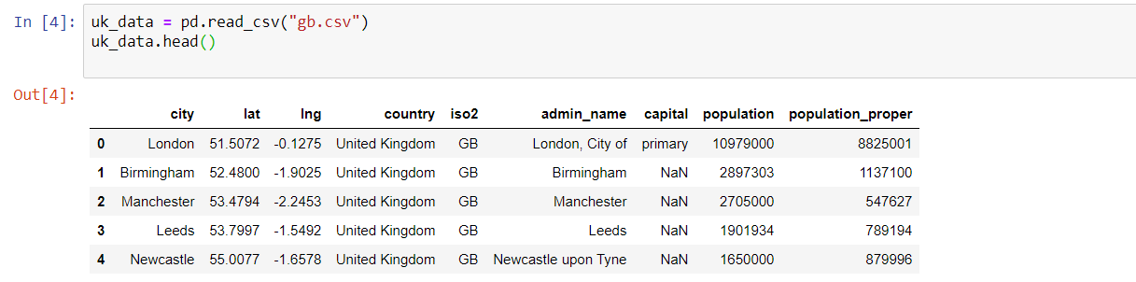import data from "[https://simplemaps.com/data/gb-cities"](https://simplemaps.com/data/gb-cities%22) site which includes data about UK cities items of population and coordinates

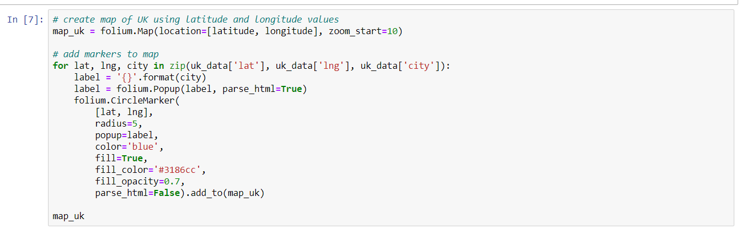Create a map of all UK showing all projected 443 cities

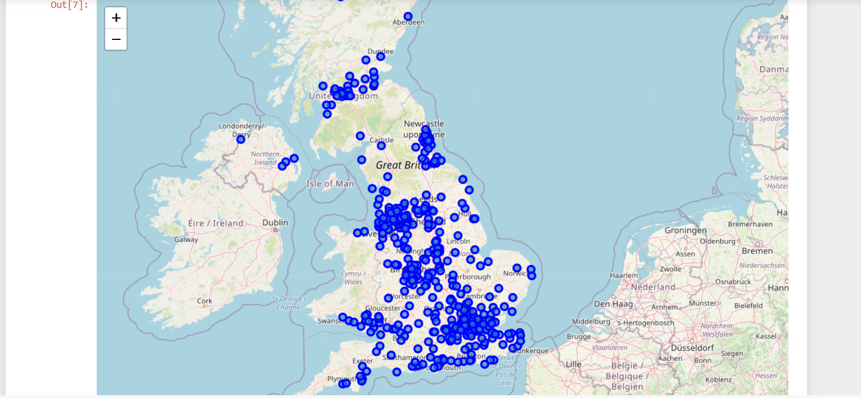

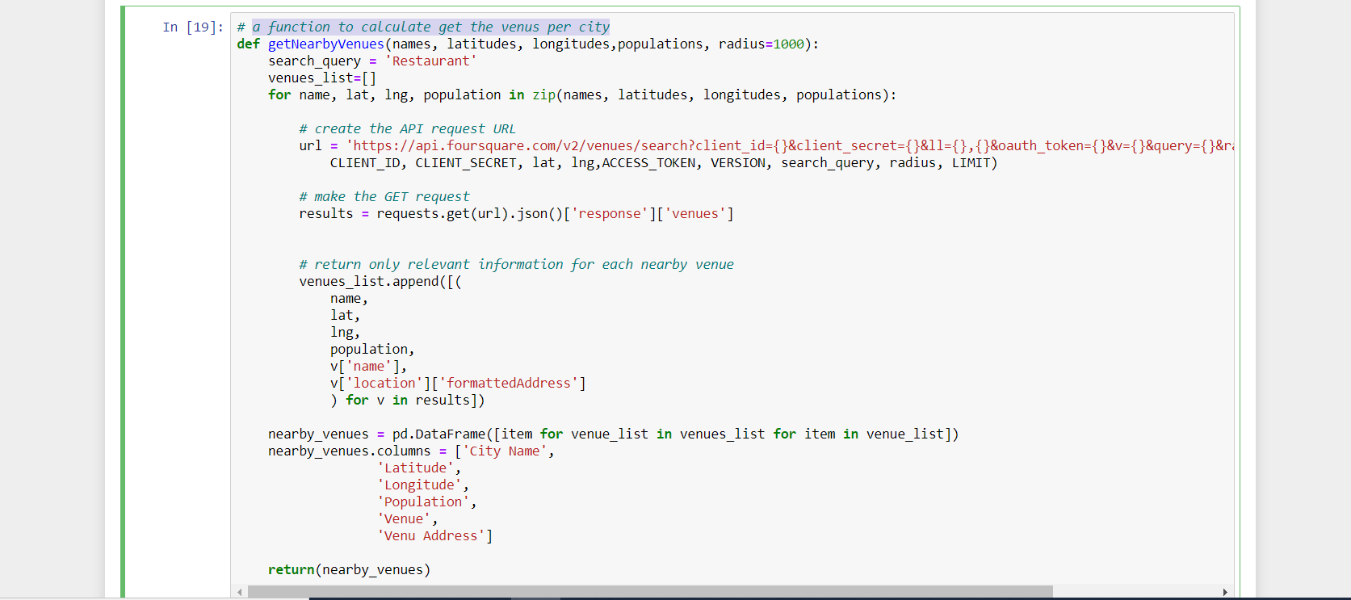Function to calculate get the venues per city

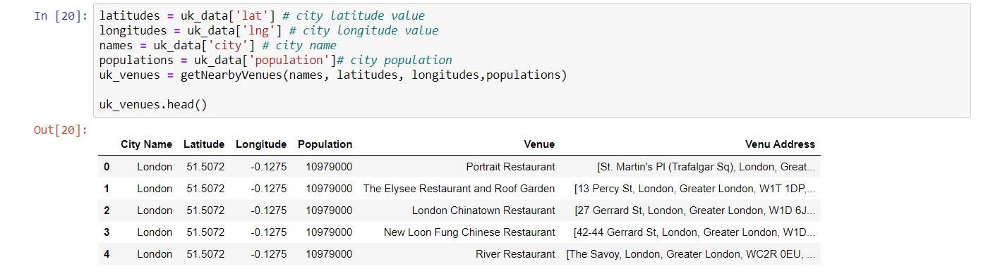A data frame created to capture all restaurant venues in all cities of UK

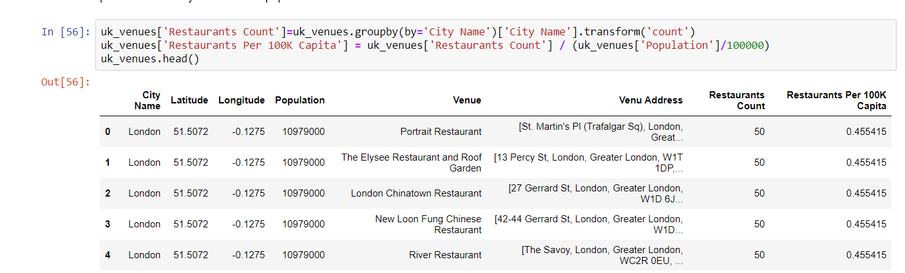A data frame including all required features with the count of restaurants per city and the restaurants per 100K person in city

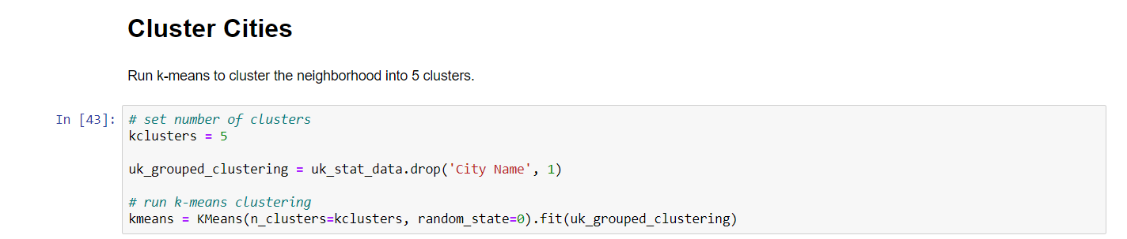Creating 5 clusters to show all cities based on k-means clustering

Clusters merged with the data frame showing all other information

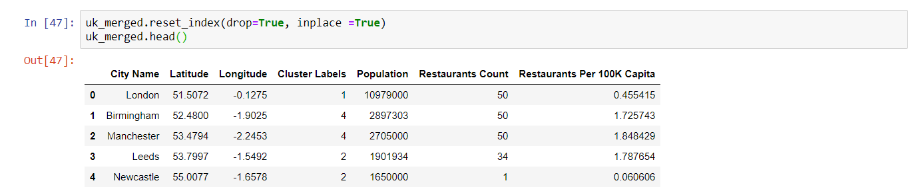

**Conclusion:**

Five different clusters were produced based on the data we collected during this project including population per city, number of restaurants per city and the Restaurant per 100K capita.

*Cluster 1*: including 357 cities with population below 1 Million and restaurant per 100K capita above 1.0. (Low Population – High Restaurant Count)

*Cluster 2*: including 1 city with population above 10 Million and restaurant per 100K capita below 1.0. (Very High Population – Low Restaurant Count)

*Cluster 3*: including 3 cities with population above 1 Million and restaurant per 100K capita above and below 1.0. (High Population – Low Restaurant Count)

*Cluster 4*: including 11 cities with population below 1 Million and restaurant per 100K capita above 1.0. (Low Population – High Restaurant Count)

*Cluster 5*: including 2 cities with population above 2 Million and restaurant per 100K capita above 1.0. (High Population – High Restaurant Count)

From above clustering it is clear for a restaurant business that clusters with "Low Restaurant Count" would be their first choice of city location and then other can follow in terms of priority

Priorities for choosing a city to open a restaurant will be from prepared clusters as follows: Cluster 2 –-> Cluster 3 –-> Cluster 5 –> Cluster 4 –> Cluster 1.

Top 4 Cities to open a restaurant in are:

1. London.
2. Newcastle.
3. Birstall.
4. Leeds.

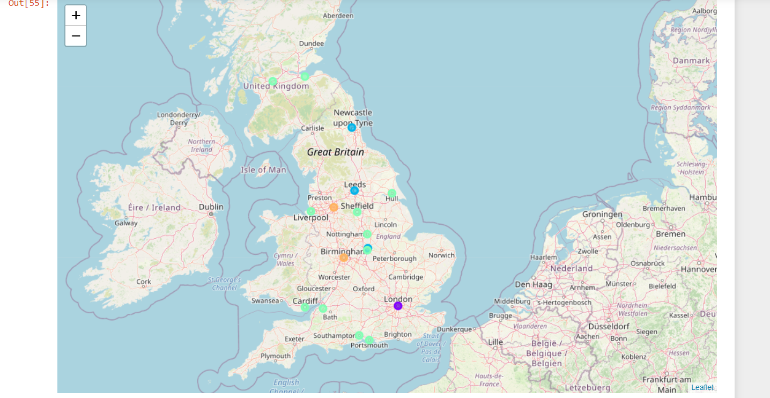A map showing the best clusters

Link to the detailed Notebook file of the code on Github:

[**https://github.com/ahmedrashwan66/Capstone-Project---The-Battle-of-Neighborhoods-UK-Cities-Restaurants-Analysis-/blob/fb250725e8899a5fde1138876e463f8cf09cb209/Capstone%20Project%20-%20The%20Battle%20of%20Neighborhoods%20(1).ipynb**](https://github.com/ahmedrashwan66/Capstone-Project---The-Battle-of-Neighborhoods-UK-Cities-Restaurants-Analysis-/blob/fb250725e8899a5fde1138876e463f8cf09cb209/Capstone%20Project%20-%20The%20Battle%20of%20Neighborhoods%20(1).ipynb)